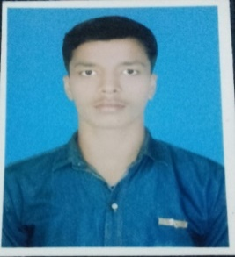
RESUME
ALOK KUMAR JHA
Contact No:+91-9205532435
Email Id: alokjha.aj1@gmail.com
PERSONAL DETAILS
- FATHER’S NAME: Rajeev Kumar Jha
- DATE OF BIRTH: 16/02/1998
- PERMANENT ADDRESS: Vill.- Nawada,P.O.-Bahera Dist.-Darbhanga, Pin.-847201 (Bihar).
- PRESENT ADDRESS: Plot 101 Khedi Enclave Opp. Little Angel School Fridabad Haryana 121004.
- LANGUAGE KNOWN: Hindi, English, Bhojpuri and Maithali.
- MARTIAL STATUS: Unmarried.
- NATIONALITY: Indian.
GENERAL QUALIFICATION
YEAR | LEVEL | UNIVERSITY/BORD | MARKS OBTAINED | PERCENTAGE
2014 | 10th | Bihar Board | 259 | 51.8%
2014 1st-sem | Diploma | W.B.S.C.T.E. | 6.8 GPA | 61.3%
2015 2nd-sem | Diploma | W.B.S.C.T.E. | 7.5 GPA | 71.2%
2015 3rd-sem | Diploma | W.B.S.C.T.E. | 6.4 GPA | 61.3%
2016 4th-sem | Diploma | W.B.S.C.T.E. | 6.8 GPA | 64.5%
2016 5th-sem | Diploma | W.B.S.C.T.E. | 7.2 GPA | 68.2%
2017 6th-sem | Diploma | W.B.S.C.T.E. | 7.1 GPA | 66.6%

CAREER OBJECTS
- To work in a challenging and dynamic environment, to keep adding values to myself and simultaneously contribute to the growth and success of the Organization.
HOBBIES
- Virtual cricket playing and Reading books.
DECLEARATION
- I hear by certify that the information furnished above is correct and complete to the best of my knowledge and belief and I bear the responsibility for the correctness of the above mentioned particulars.

Signature DATE:
Alok Kumar Jha

