CURRICULUM VITAE
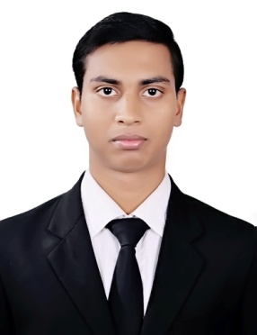
RAJESH KUMAR SATAPATHY
Nilamanideipur, PankapalSasan
Jajpur (Kalingnagar), 755026
Mobile: (+91)8984799596/8917537828
Email Id- rajeshsatapathy495@gmail.com

OBJECTIVE:
Seeking challenging assignments with a progressive organisation and execute the same using the best of my skills in turn contributing to the organizational and personal growth in Human Resourses Department.

EDUCATIONAL BACKGROUND:

PROFESSIONAL:
- Pursuing 2 years Master’s Degree in Hospitality Management under Siksha ‘O’ Anusandhan(Deemed to be University), Odisha(2017-2019).
- Completed diploma in Human Resources from Alison( e- learning ).
- Completed diploma in Six Sigma from Alison( e-learning).
- Diploma in project management from Alison
- Diploma in legal law(Alison)
- Diploma in operational management(Alison).
ACADEMIC:
- Completed 3 years Bachelor Degree in Science(Chemistry Hons.) from Utkal University, Odisha.
- +2 Science from Council of Higher Secondary Education, Odisha.
- 10th from Board of Secondary Education, Odisha.

OTHER SKILLS:
- Basic computer skills.
- National Service Schemes (NSS).

ACHIEVEMENTS:
- State Awardee in Scout and Guide.
- National Seminar (Volunteer) Awardee in College level.
- Winner Awardee in Undisputed Public Speech in College level.

STRENGTH:
- Self Motivatedandmotivative to others.
- Ready to change,learn and teach
HOBBIES:
- Reading Newspaper
- Social work
- Youtuber and Blogger.

WORK EXPERIENCE:
- Two months Industrial Training in Human Resources Department as HRTrainee at Mayfair Hotel and Resort Ltd. Bhubaneswar.
Learning Points:
- Joining Formalities of employees
- Exit Interview Procedures
- Disciplinary Action
- Training Session Class
- KPI&KRI
- HR Transformation
- Basic introduction about Labour Laws &Industrial Relation
- Leave Policies
- E.P.F &Gratuity calculation
- Employee code of conduct
- HR Policies & Locker Administration.
- Employee Engagement & Feedback on Employee Satisfaction.

PERSONAL DETAILS:
Father’s Name : Gouranga Charan Satapathy
D.O.B : 5th May 1997
Gender : Male
Nationality : Indian
Language Known : Odia, Hindi,English
Blood Group : O+ ve

Reference Persons:
Name of Person | Designation | Contact No. | Email ID
Dr. SasmitaMohanty | Training & Placement Coordinator | 9776645903 | smohanty@soa.ac.in
Abhijit Jena | Asst.Manager HR | 9238400936 | hr.lagoon@mayfairhotels.com
Rajesh Kumar | HR. Executive | 8125317051 | hr.darjeeling@mayfairhotels.com

Declaration:
I, solemnly declare that all the above furnished is free from errors to the best of my knowledge.
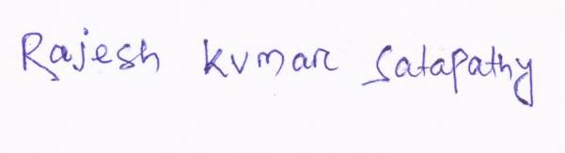

Date-
Place- Bhubaneswar Signature

