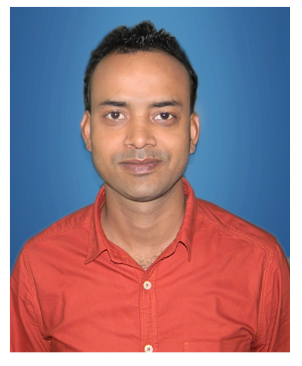
NAME- ANUP KUMAR KESHARI
Date of Birth :20/01/1990

B.TECH (ELECTRICAL AND ELECTRONICS ENGINEERING)

CONTACT
MOB : 7991185860,7562025862
E-mail : kesharianup090@gmail.com
Passport Number : M6606199

CAREER OBJECTIVE: -
To achieve a challenging position where I can effectively contribute my skills and seeking a position in Electrical Engineering (Maintenance), which offers Professional growth while being resourceful, innovative and flexible.

PROFESSIONAL EXPERIENCE: -
- Having more than 3 years of experience in plant maintenance.

- Working in Electrosteel steels ltd.Bokaro Under SRG earth resources ltd. (0.5 MPTA Vertical type Non recovery coke oven Plant) as High skilled technician in Electrical Maintenance from Sept-2013 to April 2017.

JOB PROFILE: -
- Cable Laying and Termination for MCC, Motors.
- All electrical maintenance (preventive and breakdown).
- Maintenance of MCC panel Heavy oven machines like pusher car, charging car, Guide Car, Quenching Cars, Stamping set etc.
- Maintenance of 415 V LV panel like PCC, PDB, PMCC, MCC & ACB and LV motor upto 162 KW.
- To attend the preventive as well as breakdown maintenance related to electrical controlling and power wiring of plc automated lines, & ac drives.
- Maintenance and Troubleshooting of Proximity sensors, Lever limit, ZSS, Thermocouples, RTD, safety switches of conveyors.
- Troubleshooting of Real time problems in machines, Conveyors and Feeder during breakdown and finding solution for the problems related to control .
- Effective co-ordination with contractors and sub contractors.

EDUCATION
Degree | Board / University | Year | % marks / CGPA
B.TECH. (EEE) | Punjab Technical University | 2012 | 73
INTERMEDIATE (+ 2) | B.S.E.B | 2007 | 53

RESPONSIBILITIES: -
- List down the major maintenance operations and plan for each operation
- Planning & scheduling of maintenance activities Electrical, Mechanical epuipment.
- Analysis of machinery status & efficiency for inventory control.
- Responsible for to achieve production target after commissioning of plant /equipments.
- Panel wiring & Field wiring.

PERSONAL STRENGTHS: -
- Complete the assigned task at any cost.
- Ability to understand the technical need of the work to be done.
- Confidence, Discipline, Motivation, and good hold over the job.
- Easy adaptability of the various systems.
- Self-motivation, Like Challenges, Adaptability, Strong willpower, Ability to work as team with Punctuality & obediently, willingness to learn, Responsible, Result-oriented. I am a sincere, self-motivated individual.
- My drive for hard work and the ability to take the initiatives under pressure makes me a suitable candidate for the applied profile.

SOFTWARE/COMPUTER PROFICIENCY: -
- Operating Systems : Windows7, Windows 8, Windows vista,
- Software’s : MS Office.
- AutoCad : Electrical (2D).

INTERESTS & HOBBIES
- Playing cricket and managing events.
- Listening Music

PERSONAL DETAILS: -
Fathers Name Late- Brahmdeo Narayan keshari
Gender Male
Languages Known Hindi, English, Bhojpuri.
Permanent Address At- Satgharwa,jail road,Arrah,Bihar
Contact no. 7562025862 / 7991185860
Passport no. M6606199

DECLARATION: -
I hereby declare that the above mentioned information is correct up to my knowledge and I bear the responsibility for the correctness of the above mentioned particulars.
Date:- Place: -

