AHRAZ TYAGI | Looking for a challenging opportunity to kick off my professional career with.
AHRAZ TYAGI | SUMMER TRAINING PROGRAM  * A to Z Automobiles (2017)  Duration: 4 weeks  Title: Workshop on Automobile & Engine Design  Synopsis-  - To understand the basics of automobiles  - Engine overhauling  - Steering geometry  - Denting and painting  - Sensors  * Go-kart Design and Fabrication, ISNEE (2016)  Duration: 6 weeks  Title: Go-Kart Design and Fabrication  Synopsis-  - To understand the basics of go-kart  - Designed various components of go-kart and analyse them on SolidWorks  - Manufacturing of different parts of go-kart and fabricated them all  - Testing phase  EDUCATIONAL CREDENTIALS  PROJECTS UNDERTAKEN  - Modelling of connecting rod in SolidWorks  - Go-kart  - Designing of Steering assembly in CATIA  - Designing of F1 race car tyre  CERTIFICATION  - Designing of IC Engine components in SolidWorks software  - Pro-E  - Sketch-o-car  - CATIA  - SolidWorks  - AutoCad  KEY SKILLS  - Hard Working and Team Player  - Strong academic training in Mechanical Engineering  - Well versed with designing work in Solid Works
  B.Tech ( M.E. ) | Uttarakhand Technical University | 70% (aggregate)
  12th | Aadarsh Bal Niketan ( C.B.S.E. ) | 68.8%
  10th | Aadarsh Bal Niketan ( C.B.S.E. ) | 8.8 (C.G.P.A.)
MECHANICAL ENGINEER
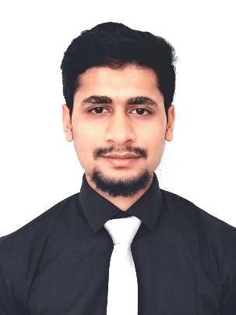
PERSONAL INFO
Phone
+91 81267 13378

Current Location
BANGALORE

Email
Ahraz.tyagi@outlook.com

Year of Birth
1996

Hobbies
Sketching

Preferred location
Anywhere in India

