DIPTY KUMARI

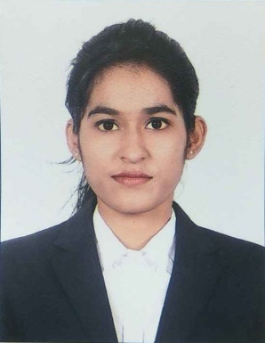
Address- Welcome PG, Bhagwan Nagar, Near Bhumkar Chowk, Wakad, Pune-411057
Mobile: +91-9082527609/ 7350910481
E-mail: diptykumari14@gmail.com
dipty.kumari@indiraicem.ac.in
Specialization: Human Resources

Education:

MBA | Indira College Of Engineering and Management, Pune | Pune University | 2017-2019 | Appearing
BCA | M.D.D.M College  Muzaffarpur, Bihar | B.R. Ambedkar  Bihar University | 2012-2015 | 65%
HSC  (Science) | SKM College,  Begusarai, Bihar | Bihar Board | 2010-2012 | 72%
SSC | Omar Girls High School, Begusarai, Bihar | Bihar Board | 2009-2010 | 72%

Project Details:

Company: Reliance Jio Infocomm Limited Pune
Project Title: Capability Building Of Employees Through Learning & Development.
Duration: 3 Months (15th May 2018 to 15th August 2018)
Details:
- Worked Under Training & Development Team.
- Conducted E-learning Training.
- Arranged Induction Program for Newly Joined Employee.

Achievements:
- In the month of May I completed 100% RFR Certification of Employees.
- In the month of July I completed 100% Mandatory Certification of Employees.
- Provide Training to 50 Employees for completing their Assessment.
- Arranged Motivational Training Schedule for Reliance Jio Infocomm Limited Employees.
- Awarded as Best Summer Intern for my work.

Company: Genesis hr services
Duration: 1 Month (24th Dec 2018 to 24th Jan 2019)
Details: Study of hiring Process (Practical knowledge of Naukri Portal, Reference check, Screening)

Computer Skills:

Operating Systems: Windows
Packages Known: MS Office (Word, PowerPoint, Excel)

Additional Qualification:

- Attended Certification of Performance Management System
- Attended workshop on Payroll Structuring
- Successfully completed Digital Marketing Certification
- Currently undergoing a 250-hour comprehensive performance-based Leadership Development Programme by Stratecent Consulting and have acquired the following skills:

- Negotiation Skills
- Problem Solving Skills
- Systems Thinking
- SPIN Selling
- Strategy

Extra-Curricular Activities:

- Coordinator of Paper Presentation at University
- Arranged Blood Donation Camps in Colleges
- Played Badminton for University Team
- Participated in FASHION SHOW and MODELLING Compitition.

Personal Details:

Date of Birth: 02/01/1995
Marital Status: Unmarried

Strengths:
- Problem Solving Approach
- Quick Learner
- Self-Disciplined
- Team Player
- Positive Attitude
- Adaptable & Flexible

Languages: English, Hindi

