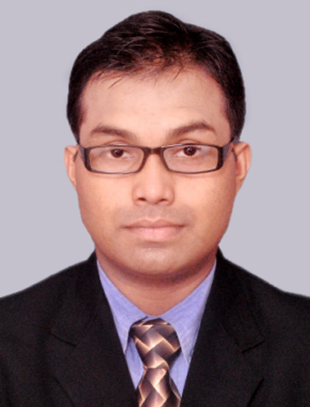
CURRICULUM VITAE

PERSONAL DETAILS :
NAME Ashok Halder
FATHER’S NAME Late Arun kumar Halder
ADDRESS 118/1,R.N.Tegore Road, Purbachal, P.O-Thakurpukur. Kolkata- 700063.
MOBILE NUMBER 6290569566
E-MAIL ID ashokhalder1983@gmail.com
DATE OF BIRTH 18th June 1983
NATIONALITY Indian
RELIGION Hindu
HEIGHT 5.3 ft (165.5cm)
WEIGHT 62kg
SEX Male
CASTE General
MARITAL STATUS Single
PASSPORT NO L8471450 (Valid till 31/03/2024)
CAREER OBJECTIVE : To perform per expectation & ensure work to be completed & delivered , have the ability & will to work & the power to line up for expectation.
SKILL SET : Good interpersonal skills & posses the quality knowledge of culinary & have the ability to create the brand new healthy & delicious recipes & coffees as & when desired or required.
LANGUAGES KNOWN : English, Hindi & Bengali.
OTHER INTEREST : Music, Cooking, Painting & any kind of creative works.
ACCADEMIC QUALIFICATION :
- Completed class 10 under W.B.B.S.E. from BEHALA KISHOR BHAROTI HIGH SCHOOL, KOLKATA in the year 1999.
- Completed class 10+2 under W.B.B.H.S.E. from BEHALA HIGH SCHOOL, KOLKATA in the year 2001.

PROFESSIONAL COURSES :
- Completed 2yrs. Advance Certificate in Food Production & Patisserie from THE CULINARY INSTITUTE, KOLKATA in November 2004.
- Completed Diploma in Food Production & Patisserie from THE CULINARY INSTITUTE, KOLKATA in November 2005 (Specialization in Indian & Continental Cuisine).
- Completed Brew Master Certification from CAFE COFFEE DAY (Amalgamated Bean Coffee Trading Co. Ltd.) in the year 2008.

PROFFESSIONAL EXPOSURE:
- Worked in HOTEL PEERLESS INN, KOLKATA (Sarovar Park Plaza Group) from November 2004 to June 2006 in the F&B PRODUCTION DEPARTMENT.
- Worked in CAFE COFFEE DAY, KOLKATA (Coffee Day Global Limited) from July 2006 to August 2010 as CAFÉ IN-CHARGE & BREW MASTER.
- Worked in IMPULSE MANAGEMENT GROUP from February 2012 to September 2013 as ASST. TRAINING MANAGER.
- Worked in IT SECTOR (International Process) from 2nd October 2013 to 28th December 2015.
- Worked in HOTEL HINDUSTHAN INTERNATIONAL, KOLKATA from 8th March 2016 to 8th November 2017 as JR. EXECUTIVE (1st COMMIE) in the F&B PRODUCTION DEPARTMENT.
- Worked in ALTAIR BOUTIQUE HOTEL, KOLKATA (AMBUJA NEOTIA HOSPITALITY) from 9th November 2017 28th April 2018 as 1st COMMIE in the F&B PRODUCTION DEPARTMENT.
- Presently associated with THE JOURNEY KING, KOLKATA ( TJK LIFESTYLE SERVICES INDIA LLP ) from 03rd August 2018 as Business Associate .

DATE : 30/03/2018 …………………………..
PLACE : Kolkata (Ashok Halder)

