Araag Batra

102, Indira Nagar Colony
Dehradun, India

Mobile : +91- 9634999669
Email : araagbatra@gmail.com

Date of Birth : 8th February 1996
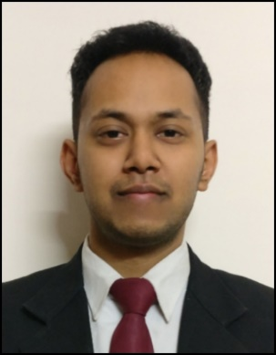
Objective
Seeking a platform for gaining practical experience by implementing my theoretical knowledge in the field of Civil Engineering.

Qualification | School/College | University/Board | Year of passing | Stream / Degree, Specialization | CGPA/ Percentage
Graduate | FST | The ICFAI University, Dehradun | 2018 | B. Tech in Civil Engineering (Gold Medalist) | 9.4/10
12th | St. Thomas' College, Dehradun | ISC | 2014 |  | 64.2%
10th | St. Thomas' College, Dehradun | ICSE | 2012 |  | 79%
Education

Internship

01/2018 – 06/2018 Construction of 2-Lane road tunnel
Dehradun, Uttarakhand M/s Bharat Construction

- Inspected steel reinforcement for raft footing as per drawing.
- Co-ordinated and supervised technical aspects of construction project.
- Provided technical advice and supervised staff on site.
- Inspected technical designs and drawings to ensure that they are followed correctly.

06/2016 – 07/2016 Construction of Flyover and Rail under Bridge
Dehradun, Uttarakhand M/s C & C Constructions Limited

- Assisted senior engineers in the inspection of all material to ensure engineer's specification and qualities are met.
- Monitored the proper compaction of subgrade layer for flyover ramp and proper placement of geogrid for its reinforcement.
- Inspected steel reinforcement and expansion joints as per drawing.
- Supervised workers for levelling (for the construction of PCC slab) using Auto-level machine.

Study Project

08/2017 – 02/2018 Strength Improvement on Nano-Composite Soil
Dehradun, Uttarakhand Department of Civil Engineering, The ICFAI University, Dehradun

- Determined the plastic limit and liquid limit of the bentonite soil using glass plate and Casagrande’s apparatus.
- Determined the optimum moisture content and maximum dry density of soil.
- Determined the shear strength of soil by Tri-Axial Shear Test.

Additional Skills
Software: AutoCAD (Intermediate), STAAD PRO (Beginner), Cadian (Intermediate), MS-Excel (Intermediate), MS-Word (Intermediate), MS-Power Point (Intermediate)
Languages: English (Fluent), Hindi (Mother Tongue)

Achievements

- Awarded Gold Medal in B. Tech in Civil Engineering from the Honourable Vice President of India, Shri Venkaiah Naidu for gaining 1st rank in academics. (Batch: 2014-18)
- National level Air Pistol Shooter.
- Volunteered as Coach in 1st ONGC Ward Shooting Camp in 2015.
- Active volunteer of "Dehradun Animal Lovers" Group for welfare of animals.
- Interests: Swimming, Badminton, Football etc.

Dehradun, 29th March 2019
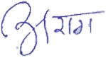
Araag Batra

