Name: Abhishek Sagar 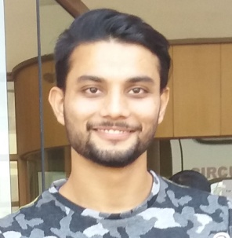

Email: sagamishraj5@gmail.com

Contact No: 8699131060

Objective
I am a consistent,hard working and highly motivated person.I enjoy working with people,I feel that I am a friendly,outgoing person.I am looking to improve my position in the work force,expand my knowledge and skill.I am also looking to establish long term employment in a friendly environment.
Academics

S. No. | Course | Institute | Board/University | Passing Year | CGPA/Percentage
1 | B.Tech (ECE) | BGIET | PTU | 2018 | 67
2 | XII | PAM COLLEGE | BSEB | 2014 | 66

Academic Trainings, Seminar and Workshops Attended

Training 1-Six week training in’ BSNL’ on wireless communication,broadband and internet,transmission media Training 2-Three months software training on “ WEB PAGE DESIGNING USING ANGULAR 2” - Three months hardware training in” EMBEDDED SYSTEM”
Academic Projects

Sr. No | Project Title | Project Description
1 | ULTRASONIC RADAR SENSOR | An ultrasonic sensor is a device that can measure the distance to an object by using sound wave.It measures distance by sending out sound wave
2 | ROBOTIC HAND USING ARDUINO AND FLEX SENSOR | Flex sensor based hand gesture controlled robot using arduino uno and zigbee is used to control the movements of robot using flex sensors attached superficially over a glove which can then be worn on our hand

Award and Achievements
My paper on “AN OVERVIEW ON 5G TECHNOLOGY”was selected in “ICAET-2017”(ISBN NO. 978-81-924893-2-2)
I secured 2nd position in district level “quiz” competition.
Personality Traits
-Leadership
-Problem solving and decision making
-Communicate effectively inside and outside the organisation
-Teamwork
-Strong work ethic
-Adaptability to different culture
Interests and Hobbies
I love playing basketball as i excel at teamwork and have leadership skills.My strength is confidence and adaptability.My weakness is i feel uncomfortable until my work is completed on time
Domain and I.T. Skills
Wireless communication, embedded system,msword excel,networking,broadband and internet,oops concept,transmission media,LAN,WAN,RAN,LTE,basic data structure
Personal Details

Name:Abhishek sagar

Gender:Male

Date of Birth:22/02/1996

Languages Known:Hindi,English

Fathers Name:Arun kumar mishra

Declaration
I hereby declare that the above written particulars are true to the best of my knowledge and belief.

Abhishek sagar

